

**Western Australian Certificate of Education**

**ATAR course examination, 2017**

**Question/Answer Booklet**

12 PHYSICS

Name

**Test 6 – Charged Particles**

|  |  |  |  |  |  |  |  |  |  |  |
| --- | --- | --- | --- | --- | --- | --- | --- | --- | --- | --- |
| Student Number: In figures |  |  |  |  |  |  |  |  |  |  |

**Mark: $\frac{}{\text{56}}$**  In words

#### Time allowed for this paper

Reading time before commencing work: five minutes

Working time for paper: sixty minutes

**Materials required/recommended for this paper**

To be provided by the supervisor

This Question/Answer Booklet

Formulae and Data Booklet

***To be provided by the candidate***

Standard items: pens, (blue/black preferred), pencils (including coloured), sharpener, correction fluid/tape, eraser, ruler, highlighters

Special items: non-programmable calculators satisfying the conditions set by the School Curriculum and Standards Authority for this course

**Important note to candidates**

No other items may be taken into the examination room. It is your responsibility to ensure that you do not have any unauthorised notes or other items of a non-personal nature in the examination room. If you have any unauthorised material with you, hand it to the supervisor before reading any further.

**Structure of this paper**

|  |  |  |  |  |  |
| --- | --- | --- | --- | --- | --- |
| Section | Number of questions available | Number of questions to be answered | Suggested working time  (minutes) | Marks available | Percentage of exam |
| Section One:  Short Answers | - | - | - | - | - |
| Section Two:  Problem-solving | 11 | 11 | 60 | 56 | 100 |
| Section Three:  Comprehension | - | - | - | - | - |
|  |  |  |  | **Total** | 100 |

**Instructions to candidates**

1. The rules for the conduct of examinations at Holy Cross College are detailed in the College Examination Policy*.* Sitting this examination implies that you agree to abide by these rules.

2. Write your answers in this Question/Answer Booklet.

3. Working or reasoning should be clearly shown when calculating or estimating answers.

4. You must be careful to confine your responses to the specific questions asked and to follow any instructions that are specific to a particular question.

5. Spare pages are included at the end of this booklet. They can be used for planning your

responses and/or as additional space if required to continue an answer.

• Planning: If you use the spare pages for planning, indicate this clearly at the top of the page.

• Continuing an answer: If you need to use the space to continue an answer, indicate in the original answer space where the answer is continued, i.e. give the page number. Fill in the number of the question(s) that you are continuing to answer at the top of the page.

6. Answers to questions involving calculations should be ***evaluated and given in decimal***

***form*.** It is suggested that you quote all answers to ***three significant figures***, with the

exception of questions for which estimates are required. Despite an incorrect final result, credit may be obtained for method and working, providing these are ***clearly and legibly set out***.

7. Questions containing the instruction "estimate" may give insufficient numerical data for their solution. Students should provide appropriate figures to enable an approximate solution to be obtained. Give final answers to a maximum of two significant figures and include appropriate units where applicable.

8. Note that when an answer is a vector quantity, it must be given with magnitude and direction.

9. In all calculations, units must be consistent throughout your working.

1. Multiple Choice [2 marks]

(a) Which diagram represents the electric field in the vicinity of a positive electric charge of magnitude Q?

|  |  |
| --- | --- |
|  |  |

(b) A positively charged particle is projected into a region of uniform magnetic field B. Which diagram represents the motion of the particle in the magnetic field?

|  |
| --- |
| B  B  **A** **B** |
| B  B  **C** **D** |

2. Figure 1 shows a piece of cotton and a plastic ruler ***before*** they are rubber together.

Figure 2 shows the piece of cotton and the plastic ruler ***after*** they are rubber together.

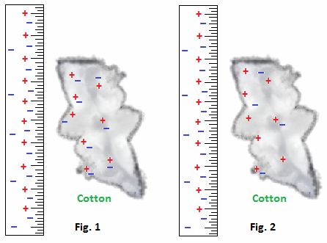

(a) Explain briefly why the ruler becomes charged. [2 marks]

(b) The plastic ruler from Figure 2 repels a rubber rod, so both the ruler and the rod have ***positive negative neutral*** charges.

Circle the correct answer/s.

Explain briefly. [1 mark]

(c) The plastic ruler from Figure 2 attracts an acetate rod, so both the ruler and the rod have ***positive negative neutral*** charges.

Circle the correct answer/s.

Explain briefly. [3 marks]

3. A student draws the following diagram to explain electrostatic induction. Comment on the accuracy of the diagram after the rod has been presented. [2 marks]

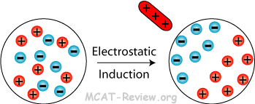

4. Consider the following diagram of an electric field around 2 point charges. The magnitude of the charge on A is Q.

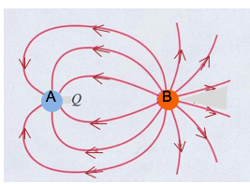

(a) State the signs of the charge on A and B. [2 marks]

A:

B:

(b) State the magnitude of the charge on B. [1 mark]

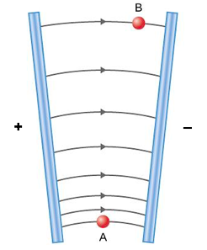

5. The diagram shows a pair of oppositely charged plates.

Explain the electric field shape and distribution in the diagram. [3 marks]

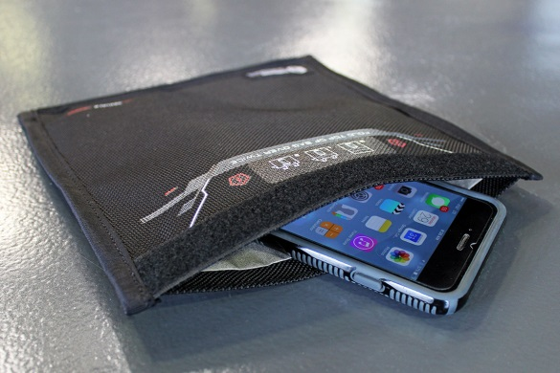6. Faraday bags are a type of Faraday cage made of flexible metallic fabric. They are typically used to block remote wiping or alteration of wireless devices recovered in criminal investigations, but may also be used by the general public to protect against data theft.

Use a diagram to explain the operation of the Faraday bag. [4 marks]

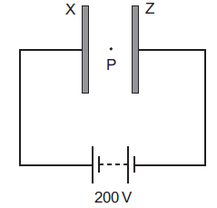

7. Two large parallel plates X and Z are placed 5.00 mm apart and connected as shown to the terminals of a 200 volt d.c. supply.

A small oil drop at P carries three excess electrons.

What is the magnitude and direction of the electrostatic force acting on the oil drop due to the electric field between the plates? [5 marks]

8. When two small oppositely charged spheres, considered as point charges, are placed in contact and separated to 1.06 m apart, the force each exerts on the other is 12.0 N.

(a) What is the charge on each sphere after contact? [3 marks]

(b) Before making contact, one of the two small oppositely charged spheres has a charge of 50.0 μC. What is the original charge on the other sphere? Show your working clearly. [3 marks]

9. An alpha particle of mass 6.68 x 10–27 kg travelling with an initial velocity equal to

2.00 x 107 ms–1 enters a region of a uniform electric field midway between the parallel plates of length **ℓ** shown below. The alpha particle is deflected so that it just passes out between the plates (i.e. at either point X or point Y).

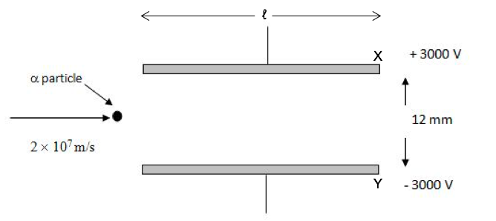

(a) On the above diagram draw the trajectory of the alpha particle. [2 marks]

(b) Determine the magnitude of the electric field strength between the parallel plates.

[2 marks]

(c) Find the acceleration of the alpha particle. [3 marks]

(d) Determine the time it takes for alpha particle to just pass out between the plates.

[2 marks]

(e) Determine the length **ℓ** of the parallel plates. [2 marks]

10. Find the direction of the force, if any, on each charged particle for each diagram shown below, where **v** is the velocity of the charge and **B** is the direction of the magnetic field.

( means the vector points inward.) [4 marks]

|  |  |  |  |
| --- | --- | --- | --- |
| Particle is Mg 2+ ion  _Pic2  .................................... | Particle is F – ion  _Pic1  ..................................... | Particle is proton  _Pic4  ...................................... | Particle is electron  _Pic3  ...................................... |

11. The path of a charged particle in a uniform magnetic field is shown below in Figure 1. It travels at 2.00 x 107 ms–1 in a plane perpendicular to a uniform 0.0100 T magnetic field.

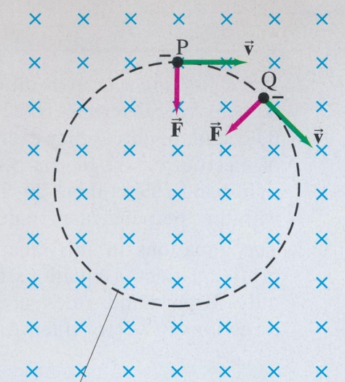

Figure 1

(a) State whether the particle is  ***positive*** or ***negative***. Circle the correct answer. [1 mark]

(b) Given that the circle shown is full-size, ***estimate*** the charge-to-mass ratio of the particle. [5 marks]

(c) Assuming that the beam of particles in (a) is positively charged and passes undeflected at 2.00 x 107 ms–1 when passing through perpendicular electric and magnetic fields.

. 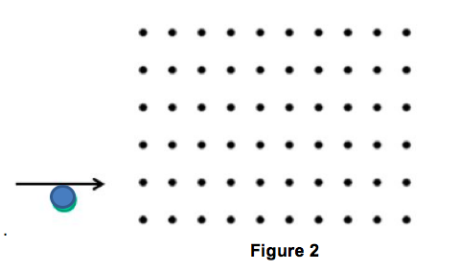

(i) If the magnitude of the electric field is 8.80 x 103 Vm–1 determine the magnitude of magnetic field. Show your working clearly, including the relevant formulae from the data sheet. [3 marks]

(ii) On Figure 2, show the direction of the electric field. [1 mark]